Weather Web- backend project

A website showing a real time weather in any area in the world



The user search for the desired city or country in the search box and the site fetch the information from an external API

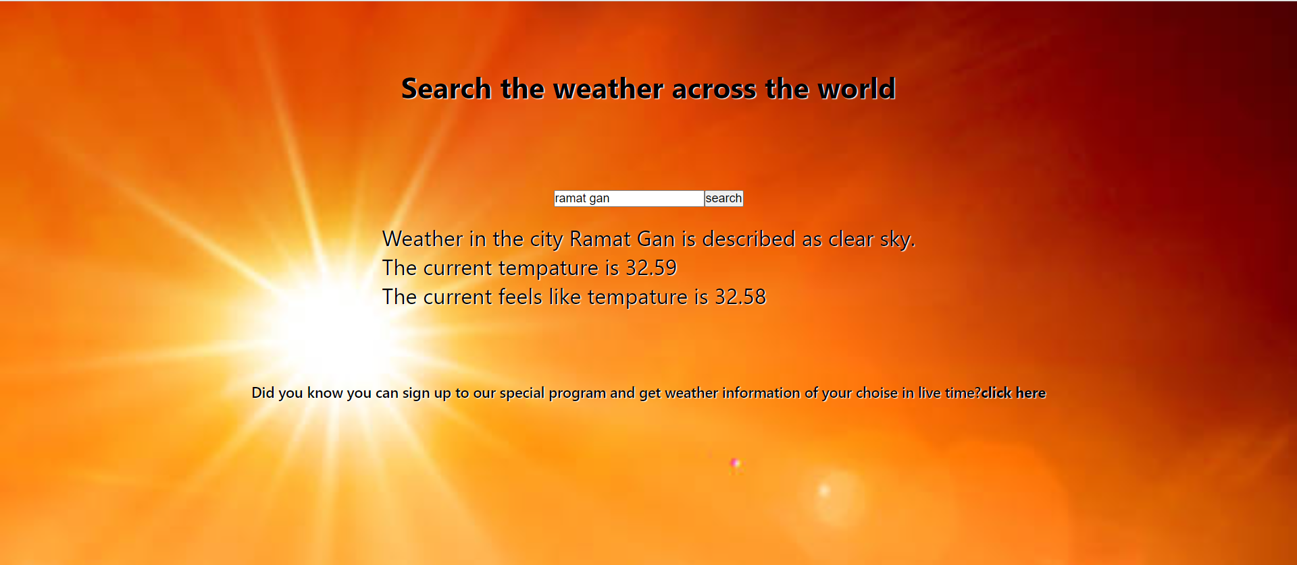

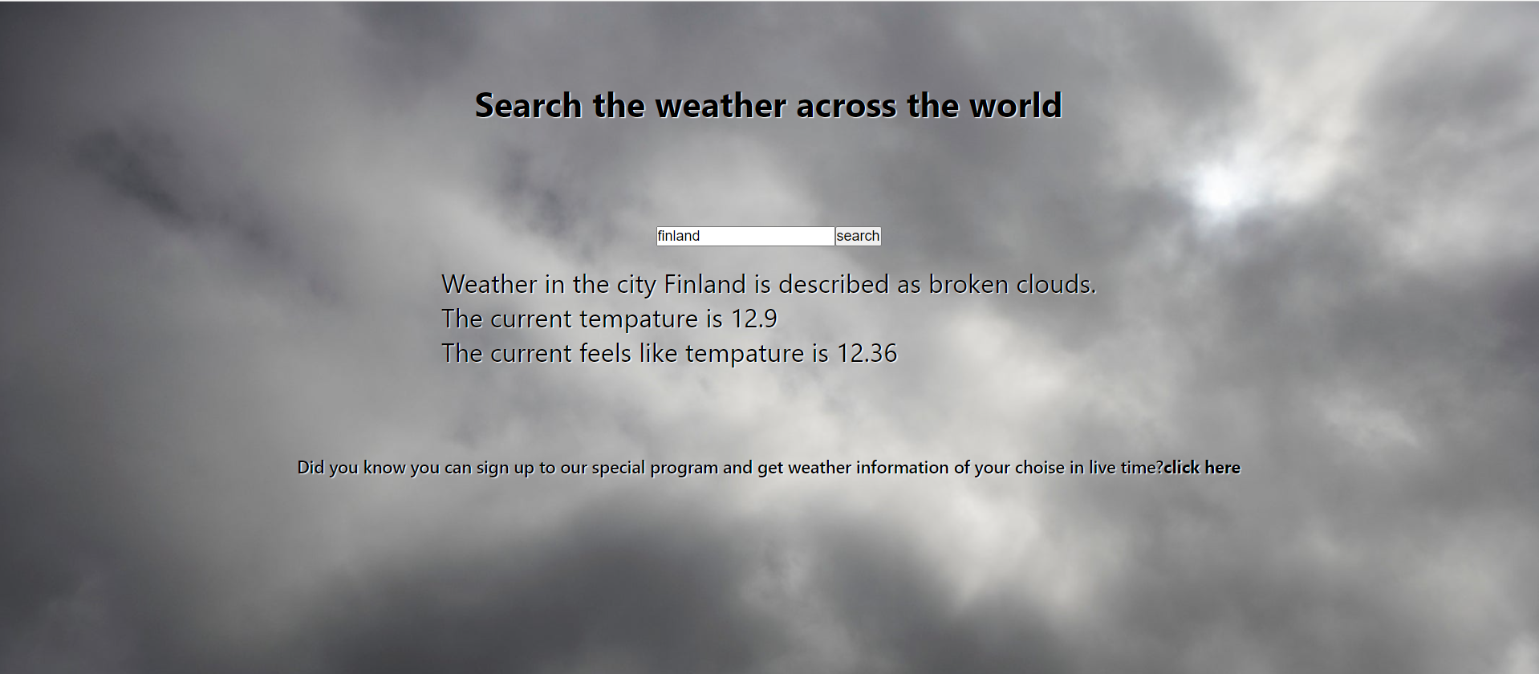

Another feature included in the web site offers the user to register on the site and enjoy the ability to receive weather reports to his email when the temperature in a chosen area crosses the selected range.

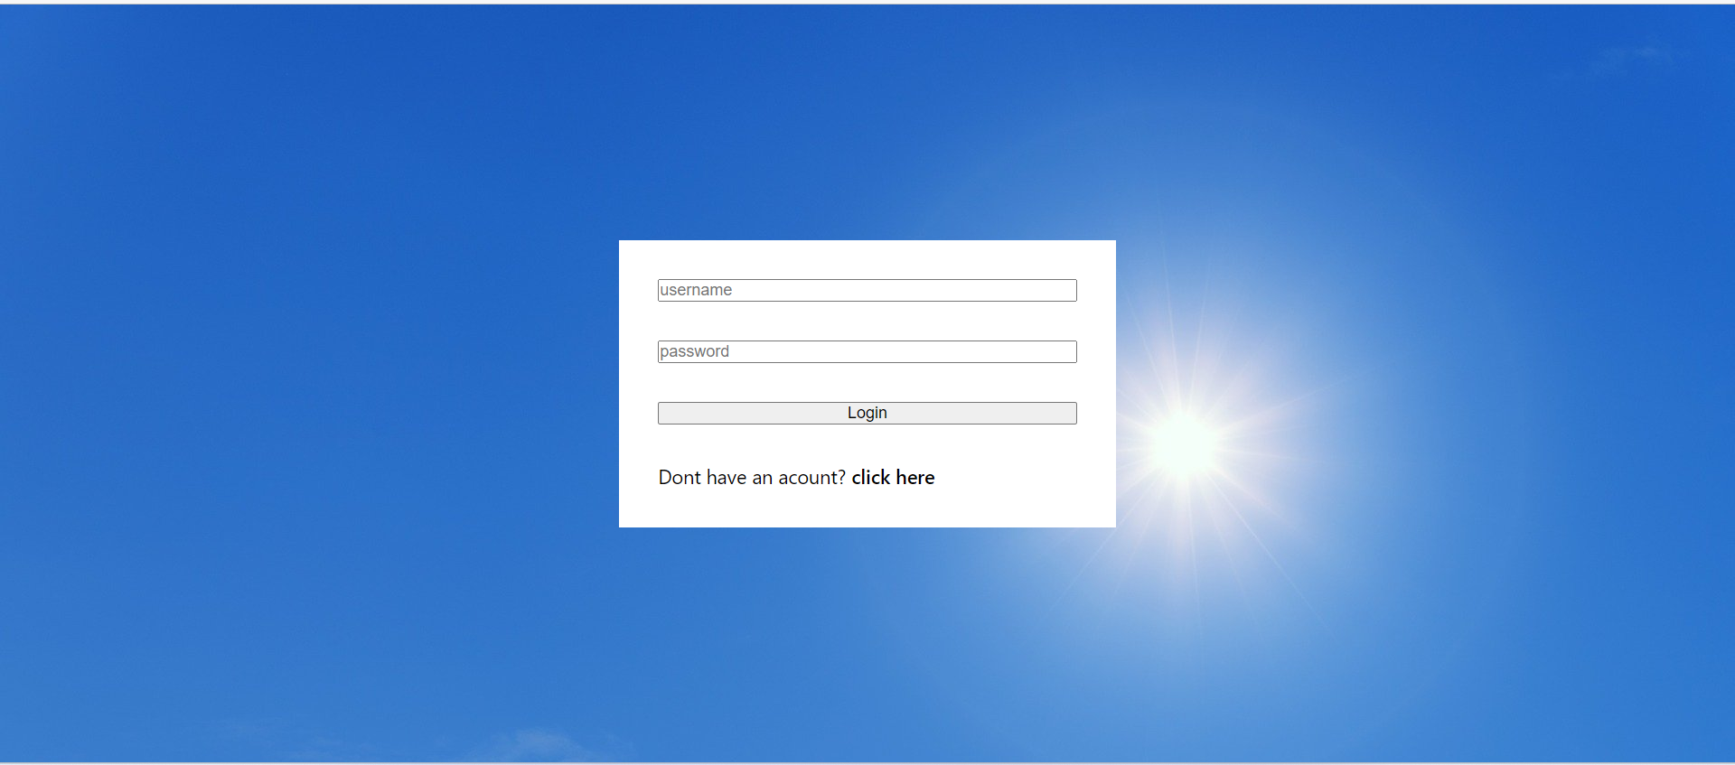

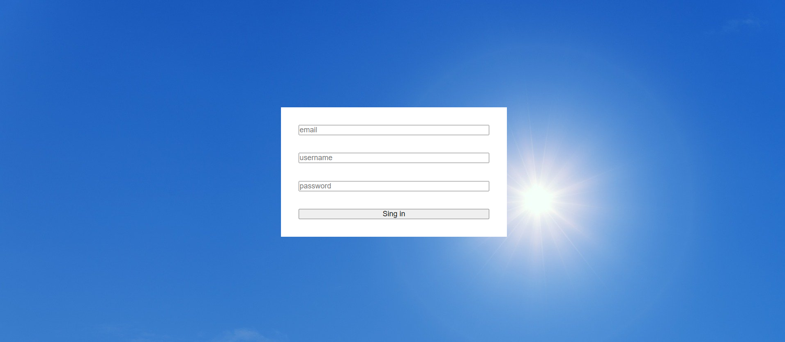

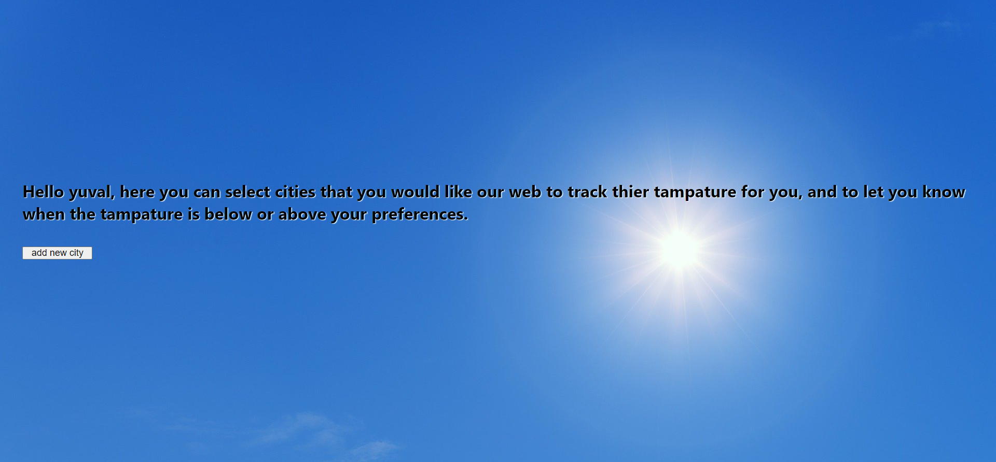

In order to receive updates to the email, the user simply needs to add his preferences to the site

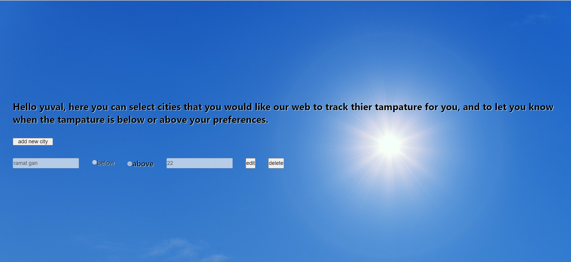

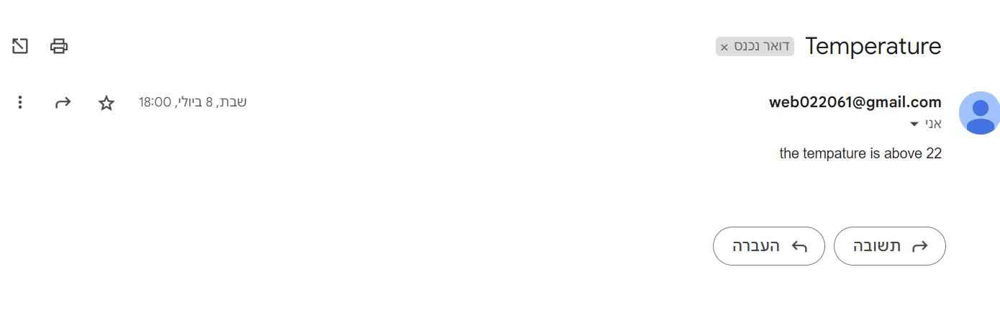

The incoming email